CO326: Industrial Networks

Lab 02A - Serial Port I/O

Introduction
The serial port, which is the industry standard with RS-232 (and RS485) is a serial communication physical interface where information is transferred serially; one bit at a time in order to communicate with the external devices/peripherals connected to the computers or controllers. In industry, serial ports (RS232 and RS485) are used extensively to connect field devices to a controller. The controller could be a Programmable Logic Controller (PLC) or an industrial PC.
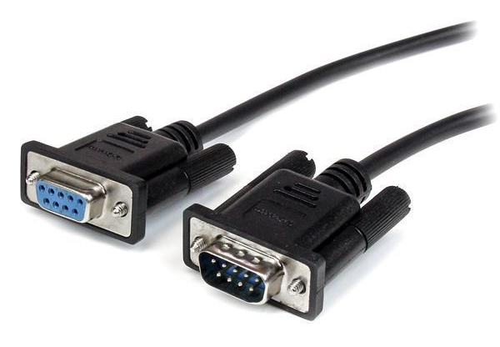
Figure 01: RS232 Serial Cable

The aims of the lab are,
- To understand the way serial interfaces are connected together to communicate between two devices.
- To develop an interface circuit that communicates with the field devices and the computer.

The lab will be done in 05 parts. In lab 02A, 3 parts will be covered.
During the online lab session, we do not have access to computers with serial ports. Therefore, in this Lab01 virtual serial ports are created. You can assume that each virtual serial port mimics a physical serial port in a computer.

Part 01: Establishing and testing a virtual RS232 serial port connection with the help of third-party tools
In this part, you will create two virtual serial ports on the same computer and establish a connection between the two with a certain wiring configuration. Finally, you will test and monitor the connection using a terminal emulator and a serial port monitoring tool respectively.

Required Tools
You will be completing this part of the lab using a few small-sized third-party tools. Therefore, you are required to download and set-up these tools before you start doing the lab. The list of tools required with a link to download each tool is given below.
- Virtual Serial Ports (14-day trial)
- https://www.hhdsoftware.com/Download/virtual-serial-port-tools.exe
- Tera Term
- https://osdn.net/projects/ttssh2/downloads/72009/teraterm-4.105.exe/
- HHD Free Serial Port Monitor
- https://www.hhdsoftware.com/Downloads

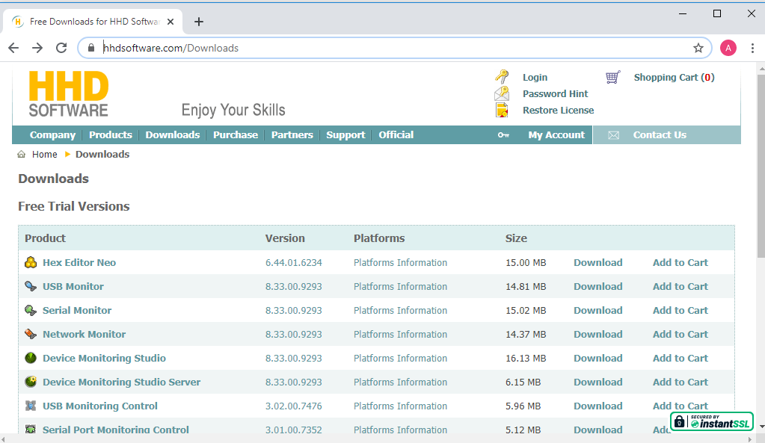

Figure 02: Screenshot of HHD free serial port monitor downloads page

Steps to Complete the Lab
- First, you need to create two virtual serial ports using “Virtual Serial Ports” software and establish a connection between them.
Here, we will be creating both the ports on the same computer and establish a local connection. Therefore, you need to choose the “Create Local Bridge” option (Figure 02).
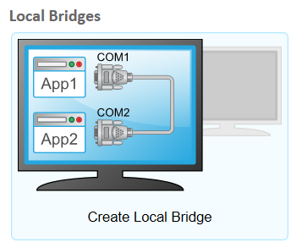
Figure 03: Screenshot of “Create Local Bridge” option
On the “Create Local Bridge” window, choose two COM port names (COM1, COM2, etc.) for the two virtual ports to be created.
Next, you can click on “Options…” button and specify the wiring configuration between the two ports being created. You can choose a pre-configured configuration such as full, loopback, etc. from the list under “Pinout scheme” (Figure 03). Or, you can create your own custom configuration by clicking on pins (remember that you should only create a connection that is supported by other hardware/software associated with the connection). Finally, click on “OK” and then “Create” to create the virtual serial port connection. On Windows, you will be able to see the new virtual serial ports getting listed in “Device Manager” under “Ports (COM & LPT)”.
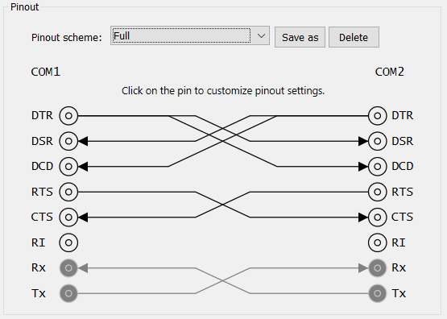
Figure 04: Screenshot of “Pinout” configuration
- Now, you should test the connection by sending some data from one port and checking whether you receive the same at the other port. This can be done by the terminal emulator software - “Tera Term”.
Open “Tera Term” and choose “Serial” from the starting window. Also, choose one of the two serial ports you have created above.
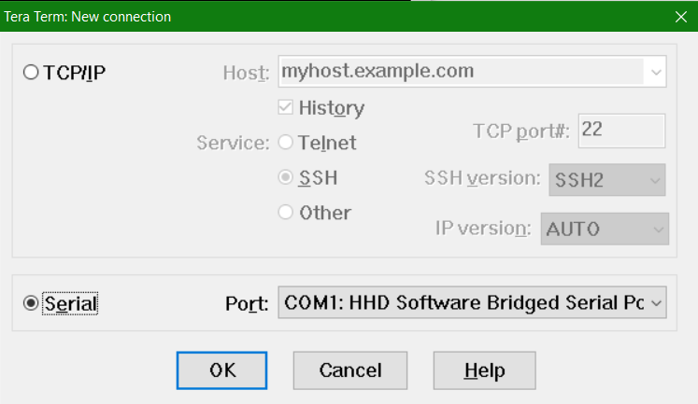
Figure 05: Screenshot of “Tera Term” starting window configuration
Now, you can send character data through the port you selected by typing letters on the terminal window you get. However, in order to see what is being received at the other port, you need to create another connection in Tera Term for the second port. You can do so by choosing File->New connection… and selecting the second virtual you have created.
You now have a full setup to test the connection. You can type something on the terminal created for the first port and check whether what you typed is being received at the second terminal.
You can try entering a new line on the first terminal and see whether that is received properly at the second terminal. If not, you should change settings on the terminal windows to get the desired behavior (Hint: see what Carriage Return, and Line Feed are).
- Further, you can see what is happening underlying when you communicate between two serial ports by monitoring the serial port connections on your computer. You can do this using the “HHD Free Serial Port Monitor” software.
  - Open Device Monitoring Studio. (NOTE: As you have downloaded the serial port monitor, the software has the modules related to the serial port monitoring only. If you want USB and other network monitoring, the respective modules can be downloaded later)
  - In the “Serial” section, select one port you’ve created (e.g. COM1) by double-clicking on the port and selecting the monitoring session as “Generic” for a simple monitoring session and clicking OK.
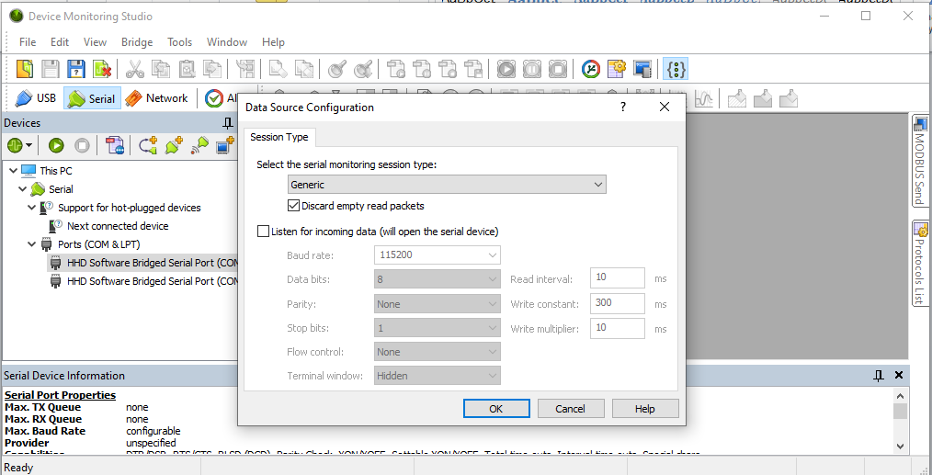
Figure 06: Screenshot of “Device Monitoring Studio” starting monitoring session
  - Then select the monitoring views from the next window. There are a number of views that can be selected. Select “Raw data view” to see the data entering, “packet view “to see the packet flow, etc.
  - Try entering data at the “Tera Term” terminal and observing the different views at the monitoring tool to identify the behavior of the data flow in the serial port communication.
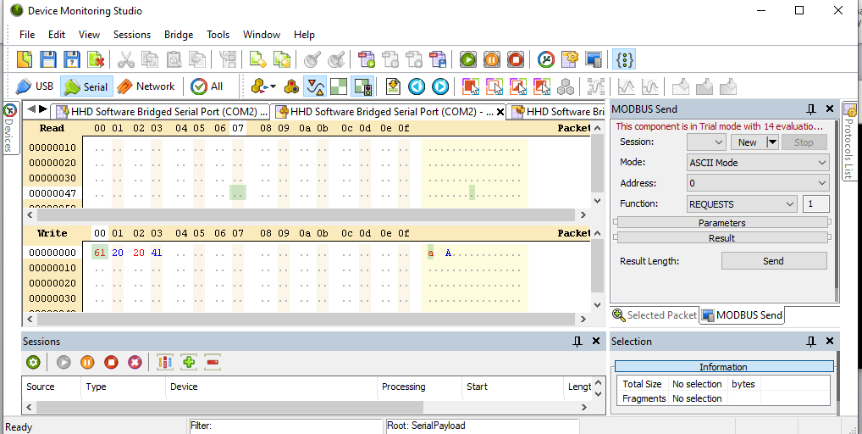
Figure 07: Screenshot of “Device Monitoring Studio” Raw data view

Submission
Take screenshots of
- Serial data (text) transfer between two virtual ports with two Tera Term terminals.
- Output of the monitoring tool when the above data transfer occurs
Create a folder named “Lab02_Part1” put the above screenshots in it and submit it along with the other submissions for Lab02A.

Part 02: Using “Proteus” to simulate one serial port
In this part, you will be using “Proteus” software to simulate one serial port connected to a virtual terminal. You will be using the same virtual ports and the virtual connection established in Part 01 for this part as well. The connection will be tested using a “Tera Term” terminal connected to one serial port and the virtual terminal in Proteus.

Steps to Complete the Lab
- As the initial step you have to implement the following setup in “Proteus”. Use a COMPIM to model a serial port and connect a virtual terminal to that serial port.
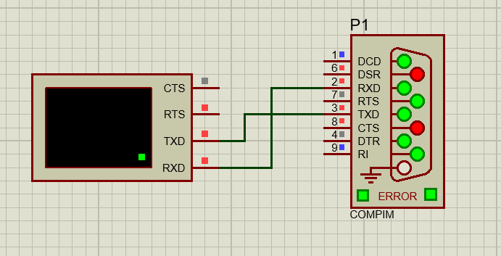
Figure 08: Screenshot of “Proteus” setup to be implemented.
- Next, you have to make this serial port one of the two virtual serial ports (e.g. COM1) you have created before. For that, using the component mode, edit the component COMPIM by double-clicking on it. In the opening “Edit component” window you have to assign the physical port as one of the two ports you’ve created (e.g. COM1).
When this setup is completed, you can run the simulation from debug -> run simulation. Once it is running, the virtual terminal corresponding to the serial port being simulated in Proteus will be opened.
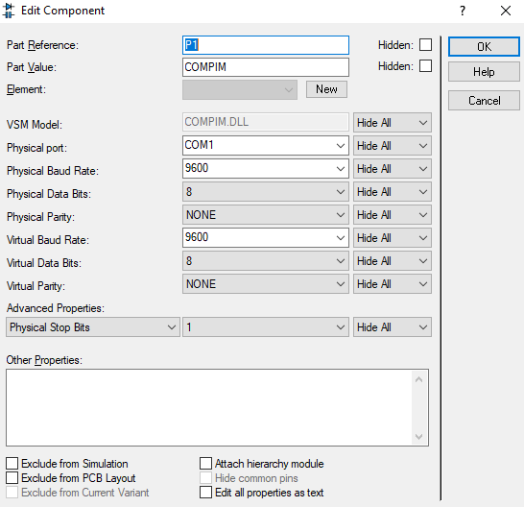

Figure 09: Screenshot of “Edit Component” window of “Proteus”
- Now, open a “Tera Term” terminal connected to your other virtual serial port (e.g. COM2).
- You can test the connection between the two ports by sending some character data from the “Tera Term” terminal to the virtual terminal in Proteus and vice versa.

Submission
Take screenshots of
- The proteus setup
- Serial data (text) transfer between two virtual ports performed with Tera Term terminal and virtual terminal in Proteus
Create a folder named “Lab02_Part2” put the above screenshots in it and submit it along with the other submissions for Lab02A.

Part 03: Using “Proteus” to simulate both the serial ports
In this part, you have to make use of “Proteus” to simulate both serial ports. You will be using the same virtual ports and the virtual connection established in Part 01 for this part as well. The connection will be tested using virtual terminals connected to each serial port being simulated in Proteus.

Steps to Complete the Lab

- Using “Proteus” to create the following setup with two COMPIM devices as Serial ports and two virtual terminals connected to each of those serial ports.
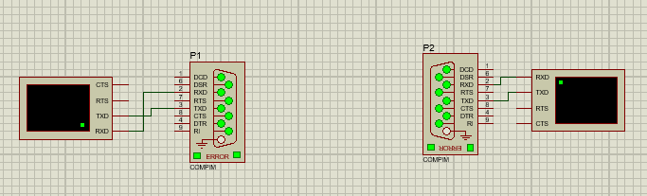
Figure 10: Screenshot of “Proteus” setup to be implemented
- Then, assign one virtual serial port (e.g. COM1) to one serial port in Proteus and the other one (e.g. COM2) to the other port. Finally, run the simulation.
- Now, you will see two virtual terminal windows being opened. You can use those two terminals to test the connection between the two ports by sending character data from one terminal and observing receiving data at the other terminal and vice versa.

Submission
Take screenshots of
- The proteus setup
- Serial data (text) transfer between two virtual ports performed with two virtual terminals in Proteus
Create a folder named “Lab02_Part3” put the above screenshots in it and submit it along with the other submissions for Lab02A.

